Flow Diagram:

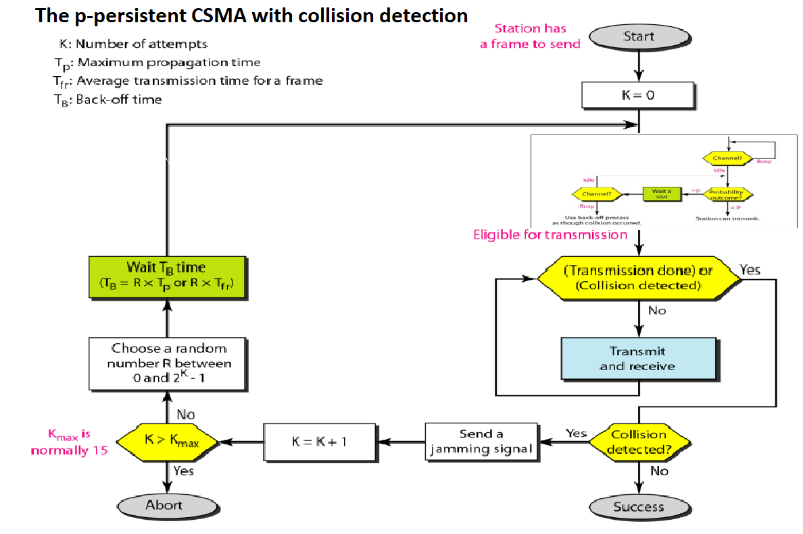

Graphs

i)Throughput and forwarding delay
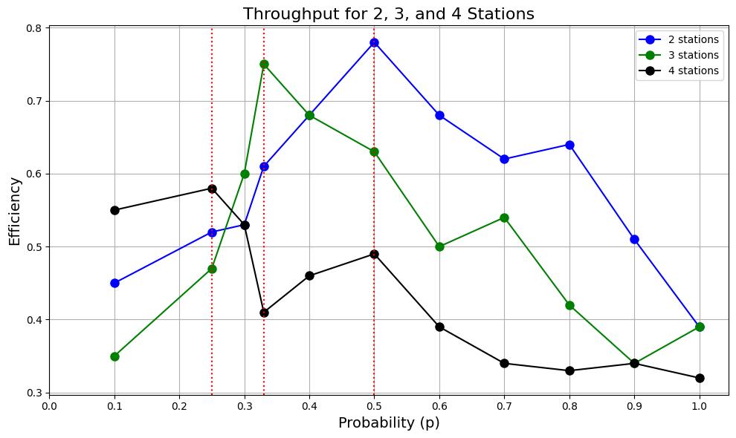
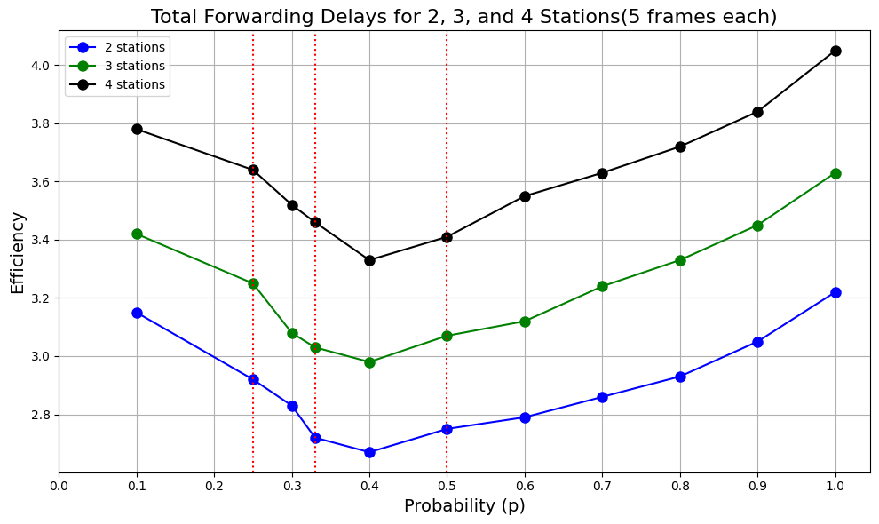

ii)Efficiency of the approach
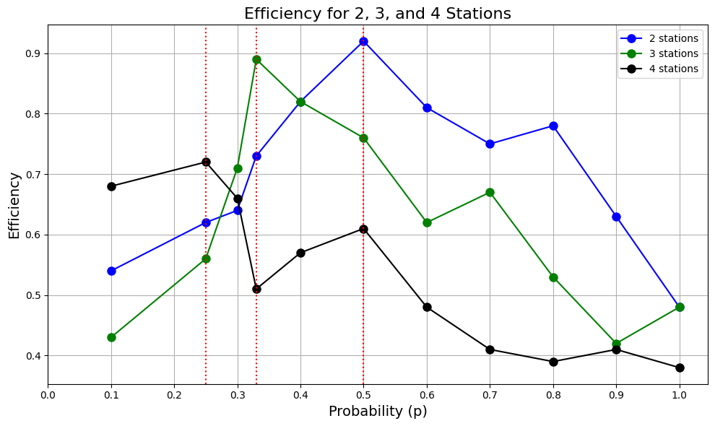

Observations
Throughput Analysis:
- General Behavior:
  - Throughput varies with the probability p, rising initially at lower values of p, reaching a peak, and then decreasing as p nears 1.
  - For each station count (2, 3, and 4), the throughput curve displays a single peak, indicating an optimal p value that minimizes idle and collision times.
- Influence of Station Count:
  - As the station count increases, the maximum achievable throughput decreases.
  - For 2 stations (blue line): Throughput is the highest across the p range, achieving peak efficiency at a higher value than configurations with more stations.
  - For 3 stations (green line): The throughput peak is slightly reduced compared to the 2-station configuration, suggesting increased contention and collision frequency.
  - For 4 stations (black line): The peak throughput is lowest, with a more pronounced drop at higher probabilities due to increased collisions in a more congested network.
- Impact of Probability:
  - Lower probabilities (approximately p=0.1−0.3p = 0.1 - 0.3p=0.1−0.3): Throughput increases as p rises since each station has a low transmission chance, minimizing idle time and collision frequency.
  - Middle probability range (around p=0.3−0.5p = 0.3 - 0.5p=0.3−0.5): Throughput reaches its peak as the system balances collision avoidance with channel utilization.
  - Higher probabilities (above p=0.5p = 0.5p=0.5): Throughput declines due to increased collision frequency, as stations are more likely to transmit simultaneously, leading to delays and reduced throughput.
- Interpretation:
  - This trend aligns with the expected behavior of p-persistent CSMA/CD, where an optimal probability enables maximum throughput by balancing idle and collision times.
  - An increased station count leads to a reduced peak throughput and faster throughput decline as p increases due to heightened collision frequency.
Forwarding Delay Analysis:
- General Trend:
  - Forwarding delay follows a U-shaped curve, decreasing initially as p increases to an optimal point, then rising again as p nears 1.
  - At low probabilities, forwarding delay is high due to extended idle times. As p increases, idle times shorten, minimizing forwarding delay until reaching an optimal level. At high probabilities, increased collisions drive up delay.
- Effect of Station Count:
  - The station count has a direct effect on average forwarding delay.
  - For 2 stations (blue line): The delay is lowest across the probability range due to fewer collisions.
  - For 3 stations (green line): Delays are moderately higher, especially at high probabilities, as collision likelihood grows.
  - For 4 stations (black line): Delay is highest, particularly at higher probabilities, owing to increased contention and collisions.
- Probability Impact:
  - Low probability (p<0.3p < 0.3p<0.3): High forwarding delay arises due to idle times, as stations are less likely to attempt transmission.
  - Optimal probability range (approximately p=0.3−0.5p = 0.3 - 0.5p=0.3−0.5): Delay is minimized as idle time reduces and network efficiency improves with fewer collisions.
  - High probability (p>0.5p > 0.5p>0.5): Delay increases with more collisions, as simultaneous transmission attempts become more frequent.
- Interpretation:
  - The U-shaped delay curve is characteristic of p-persistent CSMA/CD, where an optimal p value minimizes idle and collision-induced delays.
  - Higher station counts lead to a slightly lower optimal p and steeper delay increases at high probabilities due to more frequent collisions.
Combined Throughput and Delay Observations:
- Relationship Between Throughput and Delay:
  - Both throughput and forwarding delay reach their optimal points in a similar probability range (around p=0.3−0.5p = 0.3 - 0.5p=0.3−0.5), where throughput peaks, and delay is minimized.
  - Beyond this optimal p, throughput declines, and delay rises, due to increased collision likelihood when multiple stations attempt transmission.
- Influence of Station Count:
  - Increased station count generally leads to reduced peak throughput and increased forwarding delay, reflecting higher contention and collision probability.
  - An optimal p value that takes station count into account is crucial for maximizing network efficiency and minimizing delays.
Efficiency Analysis:
- General Efficiency Trends:
  - For all station counts, efficiency rises initially with p, peaks, and then declines as p approaches 1, demonstrating the balance between idle time and collision frequency.
- Probability Effects on Efficiency:
  - Low probability (p<0.3p < 0.3p<0.3): Efficiency is low due to high idle time, as stations are less likely to transmit.
  - Optimal probability range (around p=0.3−0.5p = 0.3 - 0.5p=0.3−0.5): Efficiency reaches its peak here, where stations use the channel effectively with minimal collisions.
  - High probability (p>0.5p > 0.5p>0.5): Efficiency falls as collision rates rise, leading to repeated backoff and retransmissions.
- Station Count and Efficiency:
  - 2 stations (blue line): Achieves the highest peak efficiency, maintaining relatively high values across the probability range. Fewer collisions enhance protocol performance.
  - 3 stations (green line): Lower peak efficiency than 2 stations, with a greater decline at higher p values due to more frequent collisions.
  - 4 stations (black line): The lowest peak efficiency, with a sharper decline at high probabilities, reflecting increased contention and collision frequency in networks with more stations.
- Key Insights:
  - The optimal probability range for peak efficiency shifts slightly lower as the station count grows, suggesting a lower transmission probability is preferable for maintaining efficiency in more crowded networks.
  - At very high p, all station counts show similar declines in efficiency due to the heightened likelihood of simultaneous transmissions, leading to frequent collisions and reduced transmission success.

